Everett E. Bowe
DAC Agent# 102705360
302-495-9404
everett.tristatefundinggroup@gmail.com
www.tristatefundinggroup.online

David Allen Capital Pre-Registration Questionnaire

What type of business do you own? | Restaurant
Do you have a website? | In-Process
Company’s average sales/month? | $5K to $19,999
Do you have a business bank account? | Yes
How many bank drops per day? | 2-3
Your plans to use the money for? | To Be Determine
When do you need the funding? | 1 - 2 Weeks

Red Flags That Could Disqualify Your Application
Submitting False or Misleading Information
Not Responding to Requests in A Timely Matter
To Many NSF (Non-Sufficient Funds) Reports
Low Or Negative Daily Balance Averages

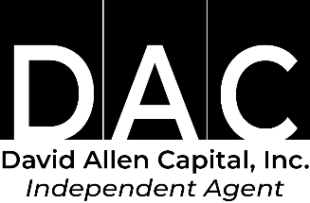
Send completed questionnaire to: everett.tristatefundinggroup@gmail.com

